Intelligent Crop Recommender

Varun Simha Reddy Thippireddy, Sree Vidya Bachina, Sai Vignesh Rayal Rolla

**Goal**:- The goal of the project is to identify the best Machine learning model for crop recommendation based on the soil and whether features from the data.

**Dataset used**:- Crop_dataset

**Major Features** :- Rainfall, Humidity, Temperature, Nitrogen Level.

**Objective**:- The decision of a farmer on which crop to cultivate is typically influenced by his intuition and other irrelevant variables, such as the desire to make quick money, ignorance of market demand, exaggeration of a soil's ability to support a particular crop, and so forth. The farmer's family's financial situation could be severely strained by a very bad decision that he made. Maybe this is one of the numerous factors contributing to the multiple farmer suicide cases that the media reports on every day. Such a wrong decision would have detrimental effects on not just the farmer's family but also the entire economy of an area in a country like India, where agriculture and associated sectors account to about 20.4% of its Gross Value Added. Because of this, we have determined that a farmer's decision on which crop to cultivate during a specific season is a very serious one. The urgent requirement is to create a system that might offer Indian farmers predictive information so they could choose which crop to produce with knowledge. In view of this, we suggest an intelligence system, that would evaluate soil characteristics such as (pH value, soil type, and nutrient concentration) as well as environmental factors such as (temperature, rainfall, and humidity) before advising the user on the most suited crop.

**Drawbacks**:- The previous methods focused on a single parameter (weather or soil) for predicting the suitability of crop development, which was one flaw we found in all these important published papers. However, in our opinion, for the best and most precise prediction, both of these criteria should be taken into account simultaneously. This is due to the fact that even while a specific soil type may be good for growing a certain crop, the yield will decrease if the local climatic circumstances are unfavorable to that crop type.

**Motivation**:- In order to overcome the aforementioned limitations, we suggest an Intelligent Crop Recommendation system that forecasts crop compatibility by taking into consideration all important variables, such as temperature, rainfall, location, and soil quality by considering such factors among them with different models to create the best accurate model based on rellavent features.

**Significance**:-

* To develop a reliable model that can provide accurate and reliable predictions of crop sustainability in a given state for a specific soil type and climatic circumstances.

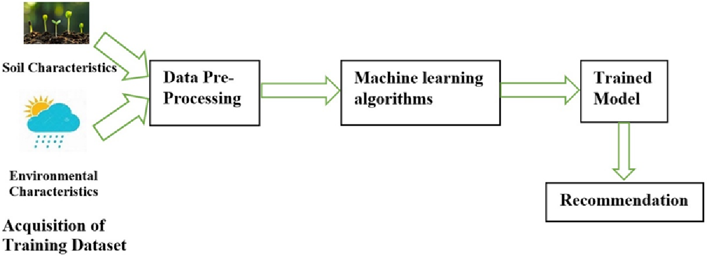

* Make suggestions for the state's best crops so that the farmer doesn't lose revenue.
* Provide crop profit analyses based on data from prior years.

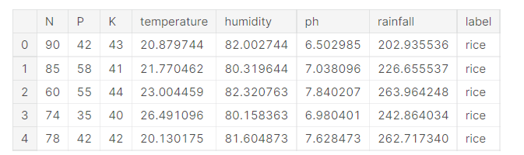

**Reference**:-

1. Rakesh Kumar , M.P. Singh, Prabhat Kumar and J.P. Singh, “Crop Selection Method to Maximize Crop Yield Rate using Machine Learning Technique”, International Conference on Smart Technologies and Management for Computing, Communication, Controls, Energy and Materials, 2015.
2. Mrs. N. Saranya, Ms. A. Mythili” Classification of Soil and Crop Suggestion using Machine Learning Techniques” International Journal of Engineering Research & Technology (IJERT) http://www.ijert.org IJERTV9IS020315 (4.0 International License.) Vol. 9 Issue 02, February-2020.
3. Keerthan Kumar T G, Shubha C, Sushma S A” Random Forest Algorithm for Soil Fertility Prediction and Grading using Machine Learning "International Journal of Innovative Technology and Exploring Engineering (IJITEE) ISSN: 2278-3075, Volume-9 Issue-1, November 2019.
4. G. Chauhan and A. Chaudhary, "Crop Recommendation System using Machine Learning Algorithms," 2021 10th International Conference on System Modeling & Advancement in Research Trends (SMART), 2021, pp. 109-112, doi: 10.1109/SMART52563.2021.9676210.
5. <https://www.semanticscholar.org/paper/Intelligent-Crop-Recommendation-System-using-Priyadharshini-Chakraborty/7df12f1c37971486869f54003727e6cc73e01769>